**Result:**

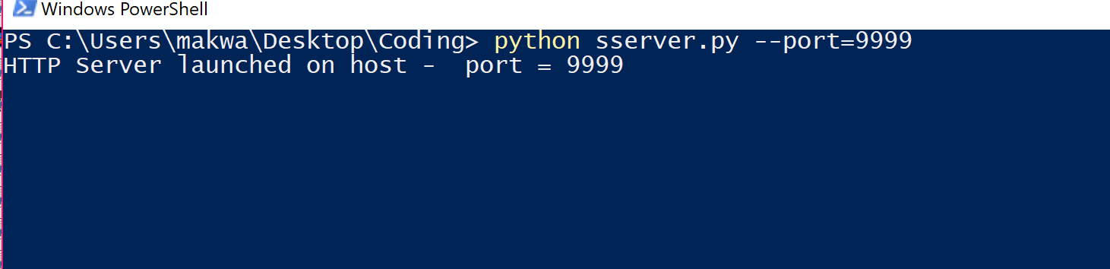

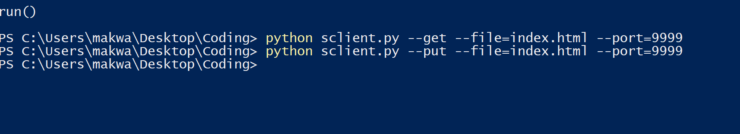

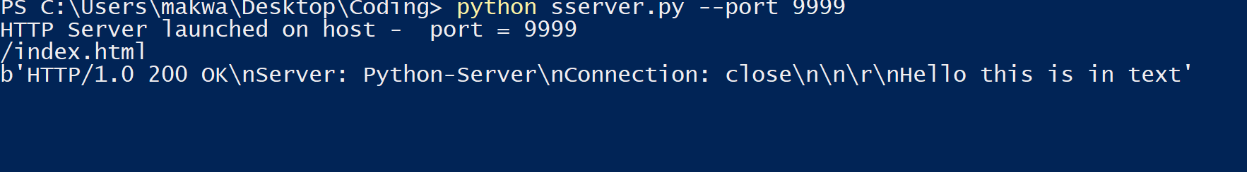

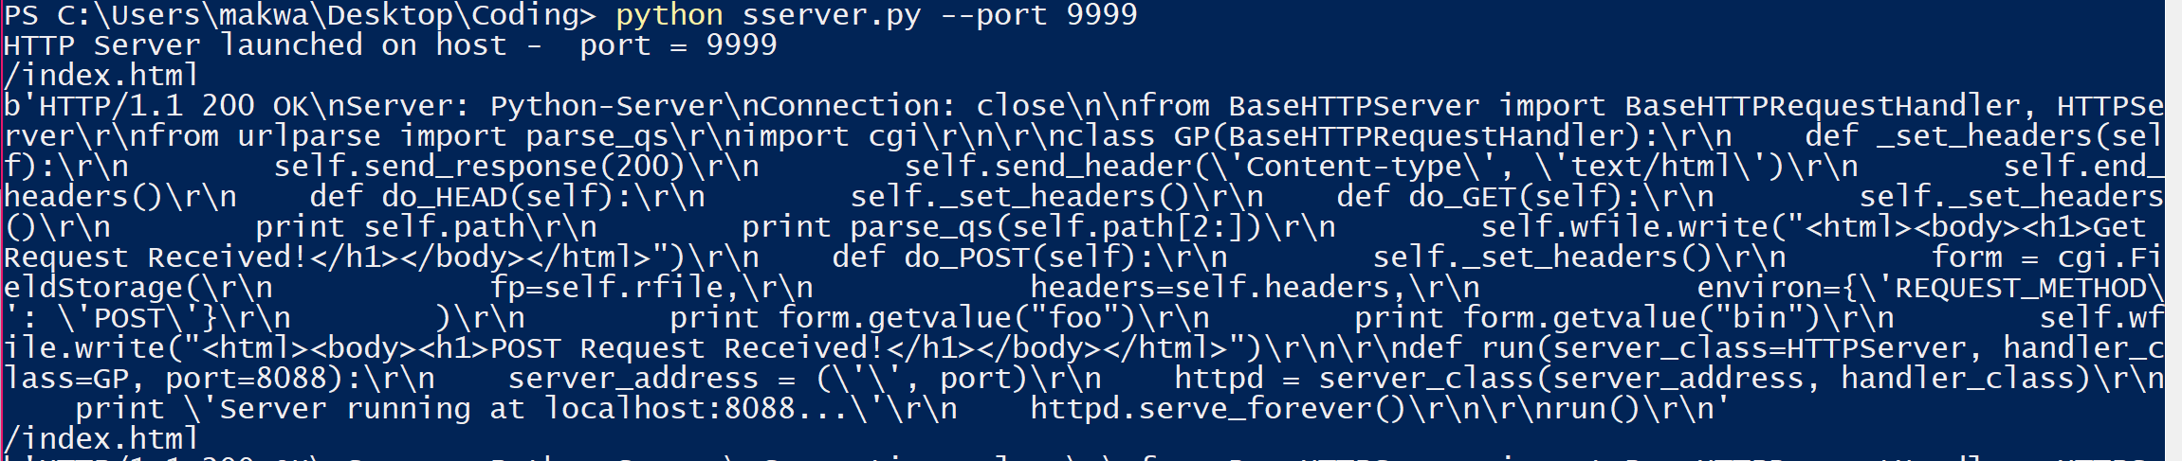

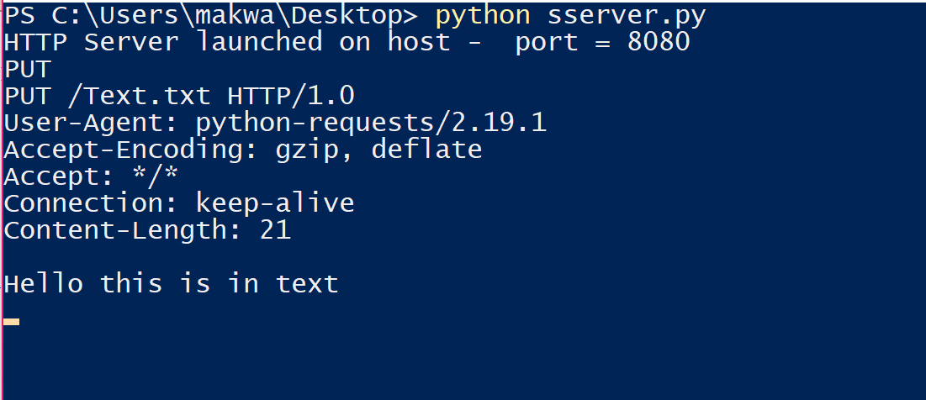

In your Python interpreter, type the following:

pip install requests

**Importing the Requests:** Module To work with the Requests library in Python, you must import the appropriate module.

You can do this simply by adding the following code at the beginning of your script:

import requests

**Making a Request:** When you ping a website or portal for information this is called making a request. That is exactly what the Requests library has been designed to do.

To get a webpage you would do something like the following: r = request.get(‘https://github.com/timeline.json’)

**Get the Content:** After a web server returns a response, you can collect the content you need. This is also done using the get requests function.

import requests r = requests.get('https://github.com/timeline.json') print r.text

# The Requests library also comes with a built-in JSON decoder, # just in case you have to deal with JSON data

import requests r = requests.get('https://github.com/timeline.json')

print r.json

**Make an HTTP Post Request:** You can also handle post requests using the Requests library.

r = requests.post(http://httpbin.org/post)

But you can also rely on other HTTP requests too, like PUT, DELETE, HEAD, and OPTIONS.

r = requests.put("http://httpbin.org/put") r = requests.delete("http://httpbin.org/delete") r = requests.head("http://httpbin.org/get")

r = requests.options("http://httpbin.org/get")